Information Theory Basic for Machine Learning & Deep Learning

Information theory
The Shannon information content is the amount of information gained when an event x occurs. Mathematically, it is defined as

For example, if a coin show heads all the time, the events are predictable and we know nothing new. Therefore, the information content is zero. If the coin is unbiased, the probability distribution is uniform and is most unpredictable on whether it will be head or tail next. Therefore, the information content is the highest. Take a second to digest it. In particular, uniform distribution leads to the highest content.
In computer science, the information content can also be viewed as the number of bits to encode the information most efficiently. Utilizing the event frequency, the optimal encoding scheme will be0b0 for head and 0b1for tail in a fair coin (or vice versa). For our discussion, we use base 2 for the log. Therefore, the information content for a fair coin flipping is -log₂(½) = 1. i.e. we gain 1-bit of information when we flip the coin once.
X is called a random variable if it holds a value derived from a random process (a stochastic process), e.g. the face value in rolling dice or the total number of heads after flipping a coin 20 times.
The value of X can be modelled with a distribution p(X). For example, let X holds the total sum of rolling ten dies. We can model X with a Gaussian distribution (according to the Central limit theorem).


Information theory is a branch of applied mathematics and electrical engineering involving the quantification of information. It aims to measure and analyze the amount of information contained in signals, data, or messages and how efficiently it can be transmitted and stored. Developed by Claude Shannon in the mid-20th century, information theory has applications in various fields, including communication systems, data compression, cryptography, and machine learning.
One fundamental concept in information theory is "entropy." Entropy represents the amount of uncertainty or surprise associated with a random variable. The higher the entropy, the more unpredictable and uncertain the variable is. Entropy is often measured in bits.
Let's break down the concept of entropy with a simple example:
Imagine you have a fair coin. When you flip it, there are two possible outcomes: heads or tails. If you were to communicate the result of the coin flip to someone who didn't know the outcome, you could use one bit of information to convey the information.
In this case, the entropy of the coin flip is 1 bit.
Now, let's consider an unfair coin, where one side is much heavier than the other, making it more likely to land on that side. In this scenario, if you know the biases of the coin, you might need less than 1 bit to convey the outcome because one side is more probable.
The entropy is lower when an outcome is more predictable, and it increases when there is more uncertainty. Entropy is a way of quantifying this uncertainty and is a key concept in information theory.
In summary, information theory, through concepts like entropy, provides a mathematical framework for understanding and quantifying information, which is crucial for designing efficient communication systems, data storage techniques, and various applications in the digital world.
Entropy
Entropy is a measure of the amount of uncertainty or surprise associated with a random variable. In the context of information theory, it quantifies the average amount of information needed to describe an event, probability distribution, or a set of data. Entropy H measures the expected information content of a random variable. To calculate the value, we sum up all information content with a weight equal to its occurrence frequency.

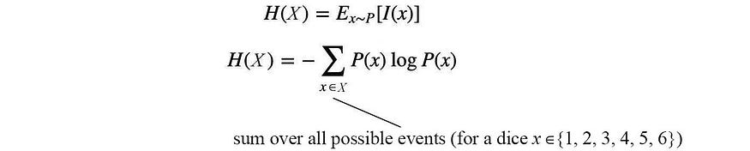
For example, in flipping a fair coin, P(X=head)=½ and P(X=tail)=½. Its entropy equals
The average content is one bit. That is, we need an average of one bit to encode an event.
Entropy establishes a lower bound for the average bits to encode events with the probability distribution P.
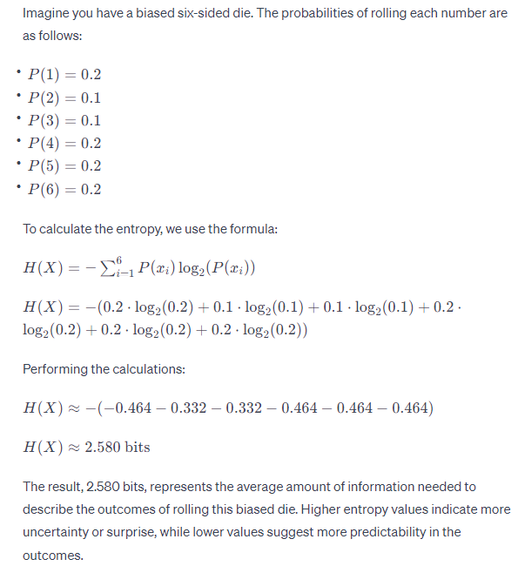

Cross-entropy
Cross entropy is a measure of the average number of bits needed to represent events from one probability distribution when using the optimal code based on another probability distribution. It's often used in the context of comparing the predicted probabilities output by a model to the true distribution of the data.
Cross-entropy H(P, Q) measures the expected number of bits to encode X with distribution P using an encoding scheme targeted for distribution Q.
In ML, we want our predictions Q to match the ground truth P. If they match, the cross-entropy will be the minimum and therefore, we often use it as our training objective.
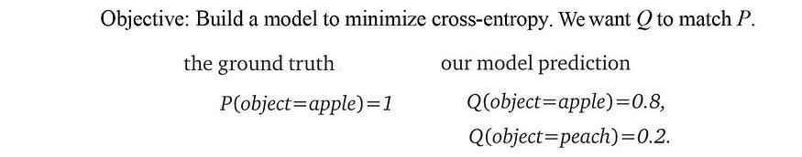
The cross-entropy for our example is
As shown above, the cost function for many classification problems is simply
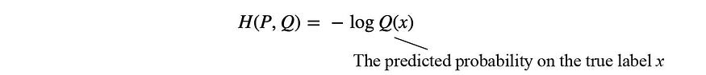

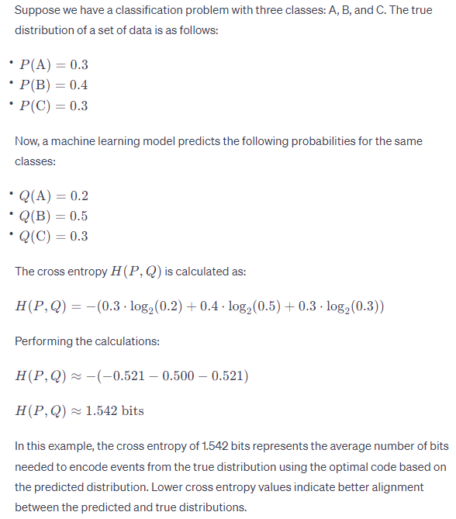

KL-divergence

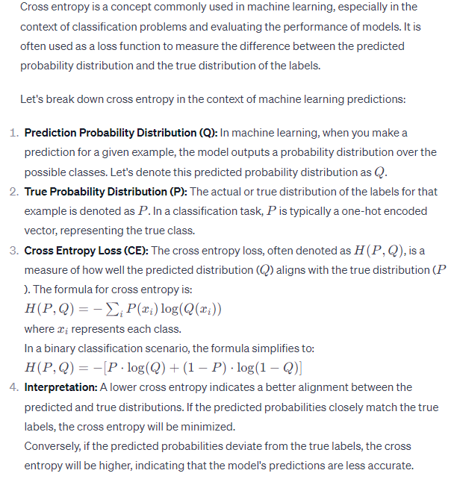
The Kullback-Leibler (KL) Divergence, also known as relative entropy, is a measure of how one probability distribution diverges from a second, expected probability distribution. It quantifies the difference between two probability distributions, providing a measure of information lost when one distribution is used to approximate the other.
KL-divergence measures the difference between two distributions P and Q.
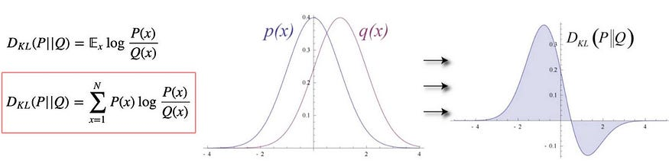
It is easy to prove that cross-entropy, entropy and KL Divergence are related:
i.e., KL-Divergence measures the inefficiency of representing P with encoding scheme Q — the extra-bits to encode the information with the sub-optimal scheme. Therefore, KL-divergence is always greater or equal to zero.
Since entropy does not change regardless of how we model it, optimizing KL divergence w.r.t. model parameters is the same as optimizing cross-entropy.

There are a few properties of the KL-divergence that need to be aware of.
KL(p, q) ≥ 0
KL(p, p)=0, and
KL(p, q) ≠KL(q, p) (non-symmetry)
KL(q, p) is called the reverse KL-divergence. The non-symmetry property of KL-divergence has some very significant implications. For example, let’s say the ground truth p is a bimodal distribution (the blue curve below) and we want to model it with a single-mode Gaussian distribution (the red curve). If KL-divergence KL(p, q) is used as the training objective function, we will get a Gaussian distribution that overlaps both modes of the ground truth p that peaks at the trough between the two modes (Diagram a). If the reverse KL-divergence KL(q, p) is used, we will either get one of the local optimal in Diagram b or c.
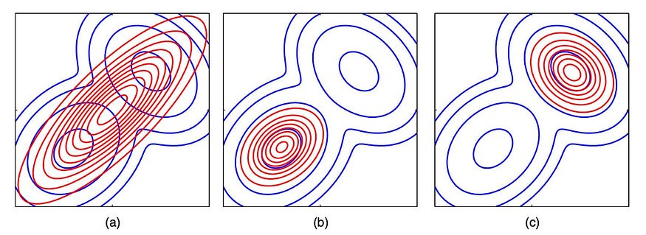
For KL(p, q), we want q(x) to be non-zero if p(x) is non-zero. Otherwise, if q(x) is small, the KL value will be high. Therefore, it tries to cover what p will cover. For KL(q, p), if P(x) is zero, we want Q(x) to be zero also.
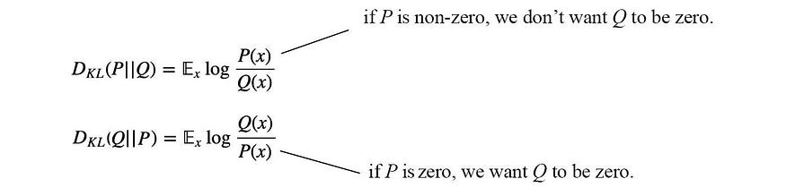
Let’s view the difference in a 2D space. Reverse KL will only cover one of the modes in a bimodal ground truth but the peak of Q will be close to the peak of one of the modes.
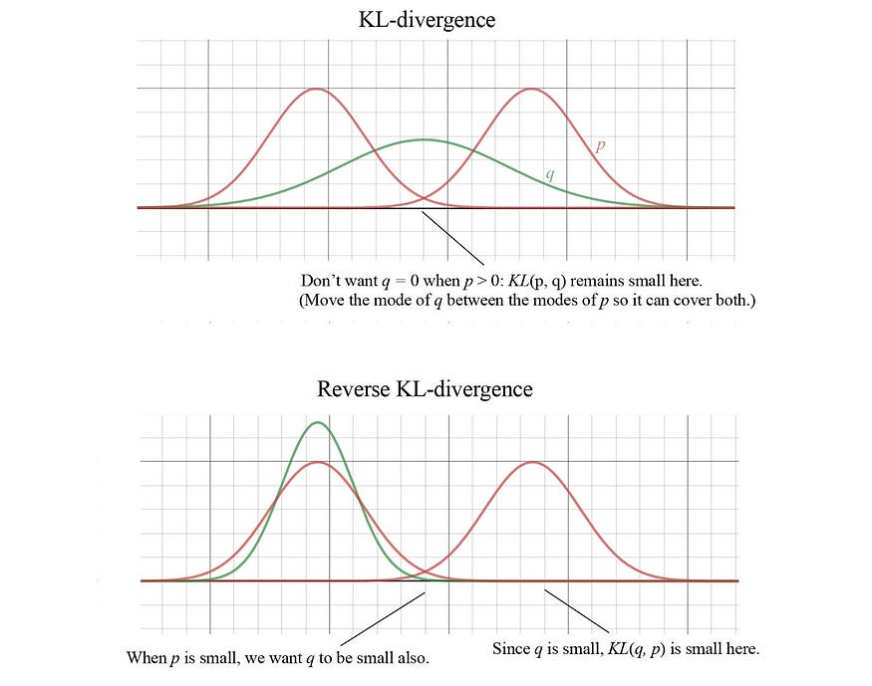
The root of the problem is we are using a simple model for complex ground truth. If both models have similar complexity, this will be a non-issue.
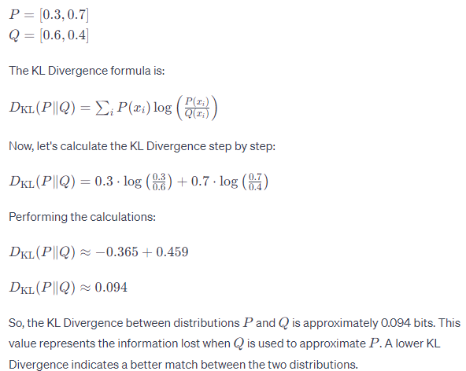

Conditional Entropy
The conditional entropy H(Y|X) is the entropy of Y given X is known. If Y can be separated according to X, this is the weighted entropy of the separated groups and calculated as:
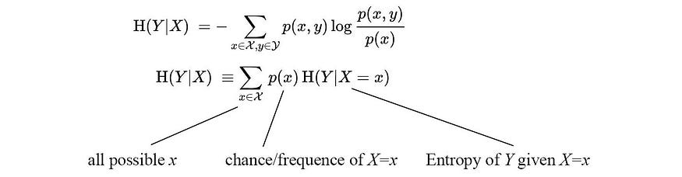

Information Gain
Mutual information (or Information gain) I(X; Y) is the information obtained on the random variable X when Y is observed. However, the mathematical definition below does not sound intuitive.
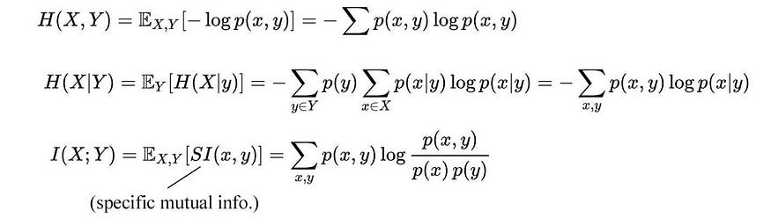
But it will be easier with entropy
Intuitively, mutual information measures how much information do we gain by knowing X? If knowing Y gives us all the information about X, the conditional entropy H(X|Y) is zero because there is no more information we needed on X. The mutual information I becomes H(X) (or H(Y)). On the other extreme, if knowing Y gives us no information about X, the conditional entropy is H(X) and the mutual information is zero.
For example, if we know the label (Y) of an object, we gain a lot of information about its raw image (X). We should not mistake its picture with other objects. Therefore the information gain I(X;Y) is high. Let’s visualize this with sets. The mutual information is its overlap.
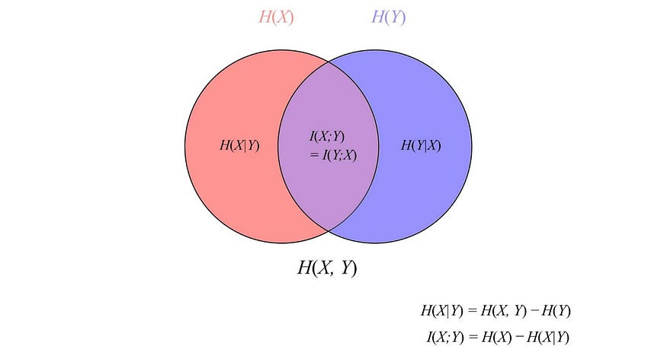
If random variables X and Y are unrelated, their intersection is empty, and therefore, the mutual information is zero. If random variables X and Y are the same, H(X)=H(Y)=I(X;Y), knowing Y is the same as knowing X.
Let’s go through some of its applications briefly. In a decision tree, we choose a condition to maximize I — a condition that gains the maximum information by separating data according to the branching condition. In another example, InfoGAN maximizes the mutual information between the generated image G and its intended label c. This encourages the GAN model to generate images related to its intended label. The information gain will be used as part of the training objective.


Implications of Information Theory in Machine Learning

A glance at what Information Theory is and how Machine Learning relies on it.

Information. This term has been thrown around in every possible scenario. But rightfully so, the world runs on Information. So, what is it? The simplest way to explain it would be through an example. Imagine you are grocery shopping and you have picked up multiple items. You know the prices of those items; hence that is raw data for you. Later, when you check out at a counter, the cashier will scan those items and give you the summed cost of the items. To elaborate, the cashier will process the number of items with the cost of each item and give you a fixed number, which you can pay. In a way, the cashier processed the raw data (individual item prices) and gave you information (final bill amount). So, I can describe information as processed data that is contextually meaningful.
To take it further, here are two messages:
a) I didn’t go to work.
b) I didn’t go to work because I had a doctor’s appointment.
It is evident that the second message contains more information than the first. But how will I define what “more” is? How do I quantify it? Here’s where Information Theory comes in! The next section will explore the field of Information Theory and the important concepts in it.

Information Theory
Researchers have pondered upon quantifying information since the early 1900s, and in 1948, Claude Shannon published a phenomenal article called “A Mathematical Theory of Communication.” This paper birthed the field of Information Theory. Information Theory, in definition, is the study of the quantification, storage, and communication of information. But it is so much more than that. It made some significant contributions to the field of Statistical Physics, Computer Science, Economics etc.
The primary focus of Shannon’s paper was on the general communication system as he was working in Bell Labs when he published the article. It established quite a few important concepts, such as information entropy and redundancy. In the present day, its core fundamentals are applied in the fields of lossless data compression, lossy data compression and channel coding.
The techniques used in Information Theory are probabilistic in nature and usually deal with 2 specific quantities, viz. Entropy and Mutual Information. Let’s take a deeper dive into these two terms.

Shannon Entropy (or just Entropy)
Entropy is the measure of uncertainty of a random variable or the amount of information required to describe a variable. Suppose x is a discrete random variable, and it can take any value defined in the set, χ. Let’s assume the set is finite in this scenario. The probability distribution for x will be p(x) = Pr{χ = x}, x ∈ χ. With this in mind, entropy can be defined as
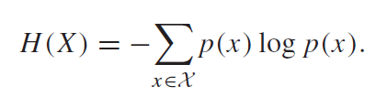
Entropy
The unit of entropy is bit. If you observe the formula, entropy is entirely dependent on the probability of the random variable and not on the value of x itself. There is a negative sign in front of the formula, making it perpetually positive or 0. If entropy is 0, there is no new information to be gained. I will demonstrate the implementation of this formula through an example.
Consider the scenario of a coin toss. There are two probable outcomes, heads or tails, with equal probabilities. If we quantify that, x ∈ {heads,tails}, and p(heads) = 0.5 and p(tails) = 0.5. If we plug in these values in the formula:
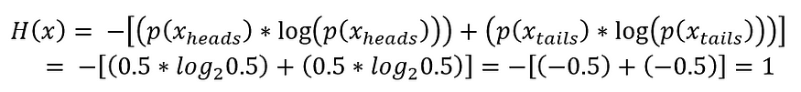
Calculating Entropy in a coin toss event
Therefore, entropy is 1 bit, i.e., the coin toss's outcome can be expressed completely in 1 bit. So, to intuitively express Shannon entropy's concept, it is understood as “how long does a message need to be to convey its value completely”. I want to dive a little deeper and discuss the concepts of Joint Entropy, Conditional Entropy and Relative Entropy.

Joint and Conditional Entropy

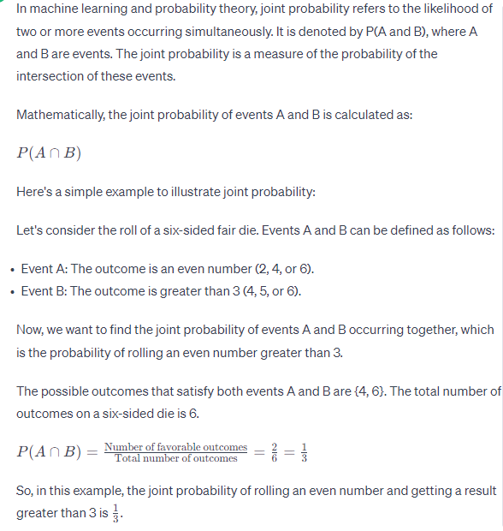
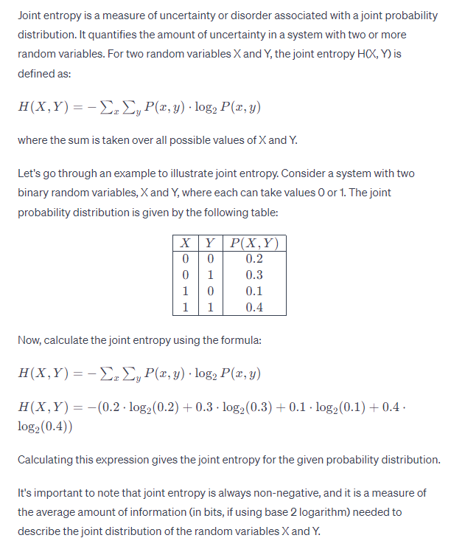
Previously, I defined Entropy for a single random variable, but now I will extend it to a pair of random variables. It is a simple aggregation as we can define the pair of variables (X, Y) as a single vector-valued random variable.
The joint entropy H(X, Y) of a pair of discrete random variables (X, Y) with a joint distribution p(x, y) is defined as
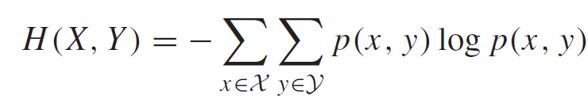
Joint Entropy
This can also be represented in terms of expected value.
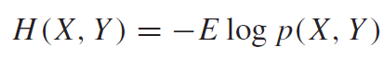
Joint Entropy (Expected Value form)
Similarly, for conditional entropy, H(Y|X) is defined as:
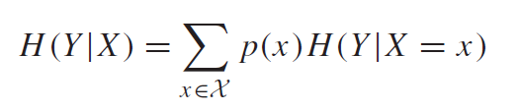
Conditional Entropy
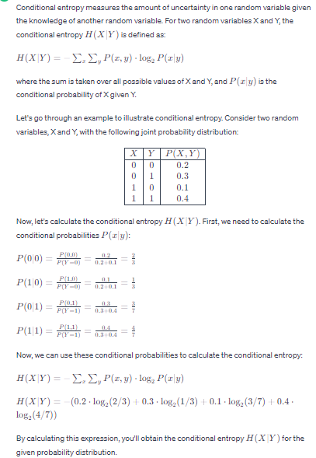
Intuitively, this is the average of the entropy of Y given X over all possible values of X. Considering the fact that (X, Y) ~ p(x, y), the conditional entropy can also be expressed in terms of expected value.
Conditional Entropy (Expected Value form)
Let’s try an example to understand Conditional Entropy better. Consider a study where subjects were asked:
I) if they smoked, drank or didn’t do either.
II) if they had any form of cancer
Now, I will represent these questions' response as two different discrete variables belonging to a joint distribution.
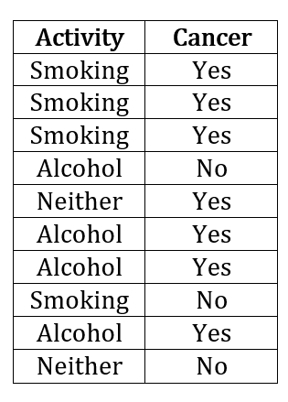
Data Table
On the left, you can see the data table where 10 subjects answered the questions. We have three different possibilities for the variable Activity (I will call it X). The second column represents whether the subject has/had cancer (variable Y). There are two possibilities here, i.e. Yes or No. Since we are not dealing with continuous variables yet, I have kept these variables discrete. Let’s create a probability table that will make the scenario clearer.
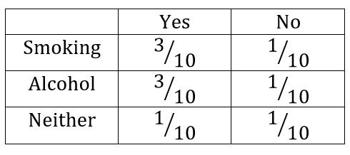
Probability Table for the above example
Next, I will calculate the value of the marginal probability p(x) for all the possible value of X.
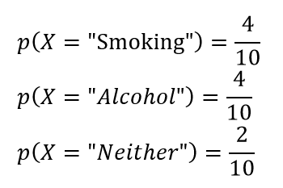
Marginal Probability of X
Based on the probability table, we can plug in the value in the conditional entropy formula.
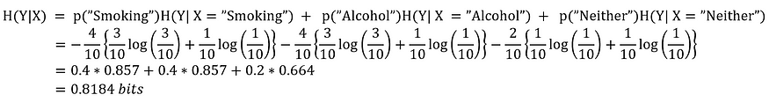
Conditional Probability in the above example

Relative Entropy
Relative Entropy is somewhat different as it moves on from random variables to distributions. It is a measure of the distance between two distributions. A more instinctive way to put it would be: Relative entropy or KL-Divergence, denoted by D(p||q), is a measure of the inefficiency of assuming that the distribution is q when the true distribution is p. It can be defined as:
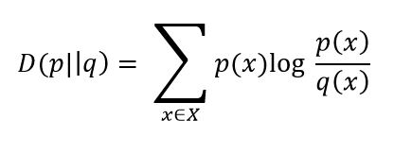
Relative Entropy
Relative entropy is always non-negative and can be 0 only if p = q. Although a point to note here is that it is not a true distance since it is not symmetric in nature. But it is often considered as a “distance” between distributions.
Lets take an example to solidify this concept! Let X = {0,1} and consider two distributions p and q on X. Let p(0) = 1 — r, p(1) = r and let q(0) = 1 — s, q(1) = s. Then,
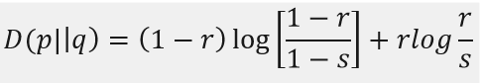
Relative Entropy for p||q
I would also like to demonstrate the non-symmetric property, so I will also calculate D(q||p).
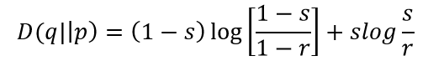
Relative Entropy for q||p
If r = s, D(p||q) = D(q||p) = 0. But I will take some different values, for instance, r = 1/2 and s = 1/4.
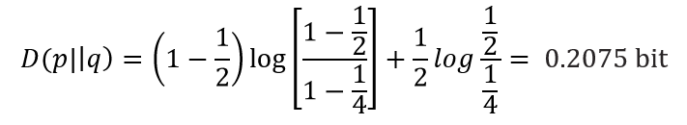
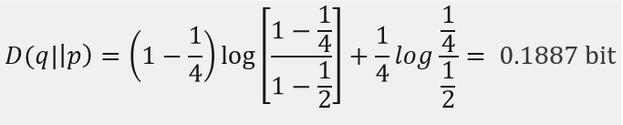
As you can see, D(p||q) ≠ D(q||p).
Now, since we have discussed the different types of entropies, we can move onto Mutual Information.

Mutual Information
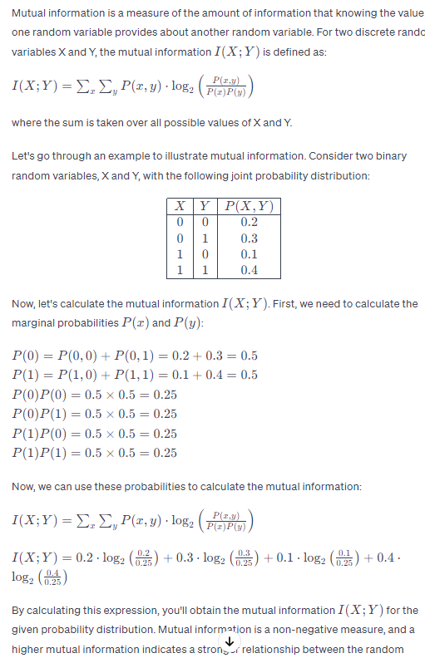
Mutual Information is a measure of the amount of information that one random variable contains about another random variable. Alternatively, it can be defined as the reduction in uncertainty of one variable due to the knowledge of the other. The technical definition for it would be as follows:
Consider two random variables X and Y with a joint probability mass function p(x, y) and marginal probability mass functions p(x) and p(y). The mutual information I (X; Y) is the relative entropy between the joint distribution and the product distribution p(x)p(y).
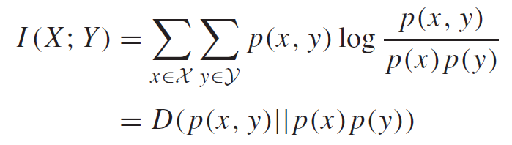
Mutual Information
log (px)
P(x) log(px)
P(x,y)log(p(x,y)
P(x,y)log(p(x,y) / p(x)
P(x,y)log(p(x,y) / p(x)*p(y)

Mutual Information can also be expressed in terms of Entropy.
Mutual Information w.r.t. Entropy
From the above equation, we see that mutual information is the reduction in the uncertainty of X due to the knowledge of Y. There is a Venn diagram perfectly describing the relationship.
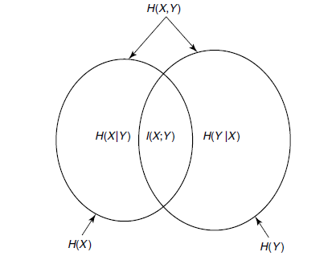
Relationship between Mutual Information and Entropy
Let’s take an example to understand it better. I can use the example of relating Smoking, Drinking, Neither with having cancer that I used while explaining entropy. We had seen that the H(Y|X) = 0.8184 bits. To calculate Mutual Information, I require one more term H(Y). H(Y), in this case, will be:
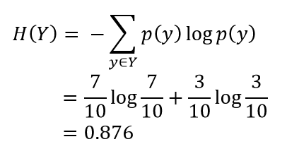
Therefore, Mutual Information is defined by:
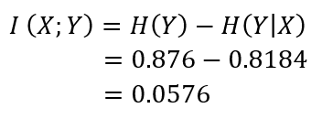
Calculation of Mutual Information
Alternatively, I can also use H(X) and H(X|Y) to calculate Mutual Information, and it will yield the same result. We can see how knowing X means so little for the uncertainty of variable Y. Let me change the passage of this example and lead you to how it all makes sense in Machine Learning. Suppose X is a predictor variable and Y is the predicted variable. Mutual Information between them can be a great precursor to check how useful the feature will be for predictions. Let us discuss the implications of Information Theory in Machine Learning.

Applications of Information Theory in Machine Learning
There are quite a few applications around, but I will stick with a few popular ones.

Decision Trees

Decision Trees (DTs) are a non-parametric supervised learning method used for classification and regression. The goal is to create a model that predicts the value of a target variable by learning simple decision rules inferred from the data features. The core algorithm used here is called ID3, which was developed by Ross Quinlan. It employs a top-down greedy search approach and involves partitioning the data into subsets with homogeneous data. The ID3 algorithms decide the partition by calculating the homogeneity of the sample using entropy. If the sample is homogenous, entropy is 0, and if the sample is uniformly divided, it has maximum entropy. But entropy does not have direct implication on the construction of the trees. The algorithm relies on Information Gain, which is based on the decrease in entropy after a dataset is split on an attribute. If you think intuitively, you will see that this is actually Mutual Information that I had mentioned above. Mutual Information decreases the uncertainty of one variable given the value of the other. In DT, we calculate the entropy of the predicted variable. Then, the dataset is split based on entropy, and the entropy of the resultant variable is subtracted from the previous entropy value. This is Information Gain and, obviously, Mutual Information in play.
10 – feature 6 . less information, purity 5, 5
4 – 3 , 7

Cross-Entropy
Cross entropy is a concept very similar to Relative Entropy. Relative entropy is when a random variable compares true distribution p with how the approximated distribution q differs from p at each sample point (divergence or difference). Whereas cross-entropy directly compares true distribution p with approximated distribution q. Now, cross-entropy is a term heavily used in the field of deep learning. It is used as a loss function that measures the performance of a classification model whose output is a probability value between 0 and 1. Cross-entropy loss increases as the predicted probability diverge from the actual label.

KL-Divergence
K-L Divergence or Relative Entropy is also a topic embedded in the deep learning literature, specifically in VAE. Variational Autoencoders take in input in the form of Gaussian Distributions rather than discrete data points. It is optimal for the distributions of the VAE to be regularized to increase the amount of overlap within the latent space. K-L divergence measures this and is added to the loss function.
K-L Divergence is also used in t-SNE. tSNE is a dimensionality reduction technique that is mainly used to visualize data in high dimensions. It converts similarities between data points to joint probabilities and tries to minimize the Kullback-Leibler divergence between the joint probabilities of the low-dimensional embedding and the high-dimensional data.

Calculating imbalance in target class distribution
Entropy can be used to calculate target class imbalances. If we consider the predicted feature as a random variable with two classes, a balanced set (50/50 split) should have the maximum entropy as we saw in the case of the coin toss. But if the split is skewed and one class has a 90% prevalence, then there’s lesser knowledge to be gained, hence a lower entropy. Implementing the chain rule for calculating entropy, we can check whether a multiclass target variable is balanced in a single quantified value, albeit an average that masks the individual probabilities.

Performing classification – A, B and A is 80 percent and B is 20.

